—————————————————————-
--- How to use resonance1011 app
—————————————————————

resonance1011 is a simple app to predict any grid, add new grid, show enf of a wav file. To run this, first libsvm has to be installed in Matlab.

** This app was built on MATLAB 2015a. It may not be backward compatible with previous versions.

=================
Installation of Libsvm
=================

- Libsvm installation files are on the ‘libsvm-3.20’ folder in the main application directory. Go to libsvm-3.20/matlab folder to start installation.

- Type 'make' to build 'libsvmread.mex', 'libsvmwrite.mex', 'svmtrain.mex', and 'svmpredict.mex'.

>> make

If make.m does not work on MATLAB (especially for Windows), try 'mex -setup' to choose a suitable compiler for mex. We have used Microsoft Visual Studio Professional 2012 as our mex compiler. For a list of supported /compatible compilers for MATLAB, please check the following page: http://www.mathworks.com/support/compilers/current_release/
Then type 'make' to start the installation.

Example:

- matlab>> mex –setup

(MATLAB may show the following messages to setup default compiler)
Please choose your compiler for building external interface (MEX) files:
Would you like mex to locate installed compilers [y]/n? y
Select a compiler:
[1] Microsoft Visual C/C++ version 7.1 in C:\Program Files\Microsoft Visual Studio
[0] None
Compiler: 1
Please verify your choices:
Compiler: Microsoft Visual C/C++ 7.1
Location: C:\Program Files\Microsoft Visual Studio
Are these correct?([y]/n): y

- matlab>> make

- Finally add the folder with the generated binaries to the MATLAB search path:

>> addpath('/path to libsvm/matlab')
(here instead of 'path to libsvm', you should put the full pathname of libsvm directory)

=================
Running the app
=================

Run resonance1011.m script from the main application directory. (Make sure that “\libsvm-3.20\matlab” folder is added to the MATLAB search path using “Set Path” option). A GUI will appear then.

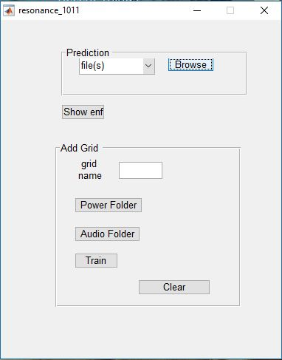

With the app you can do the following tasks:

- Grid prediction
- Show ENF
- Train the classifier with a new grid (this option is temporarily disabled for future task)

- Grid prediction

To predict a new grid or collection of grids, go to prediction panel. Select folder to predict all files of a folder or file(s) to select single or multiple files from the dropdown menu. Then press Browse button to select the file(s) or folder.

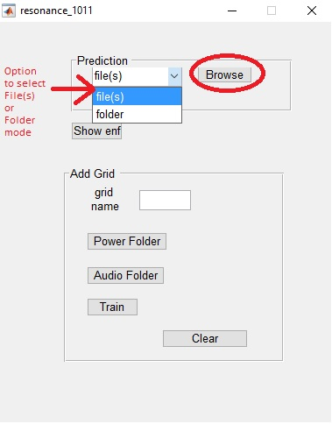

The prediction will appear shortly in a message box.

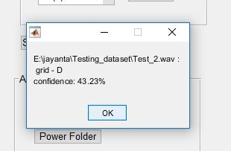

If the number of files is more than 10, the result will be written in result.txt in the application directory.

- Show ENF

To show ENF of any wav file, press Show enf button and provide the file path. The ENF signal Plot will appear.

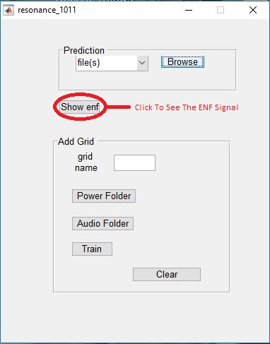
- Train the classifier with a new grid

(We have temporarily disabled the clear and train button for future task)

To add a new grid in the classifier, go to Add Grid panel. In the grid name edit box, provide the new grid name. Then press Power Folder and Audio Folder to provide the power and audio folder of the .wav files of new grid. Then press train to make classifier with the new grid.

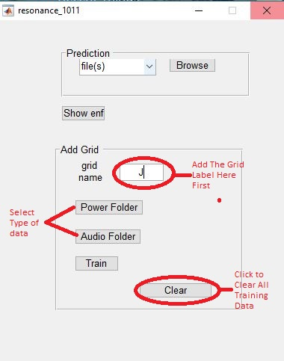

****grid ‘A’ to ‘I’ is given in the classifier by default, provide grid name ‘J’ if you want to add new grid

*** Only one additional grid can be added

If the newly added grid has to be cleared, press Clear button, then press Train button again to change the classifier.

